What is Data Science - Final Assignment

Based on the videos and the reading material, how would you define a data scientist and data science? **(3 marks)**

**I would define a data scientist as someone who finds solutions to problems by analyzing big or small data using appropriate tools and then tells stories to communicate the findings to the relevant stakeholders.**

**I would define data science as something that data scientists do.**

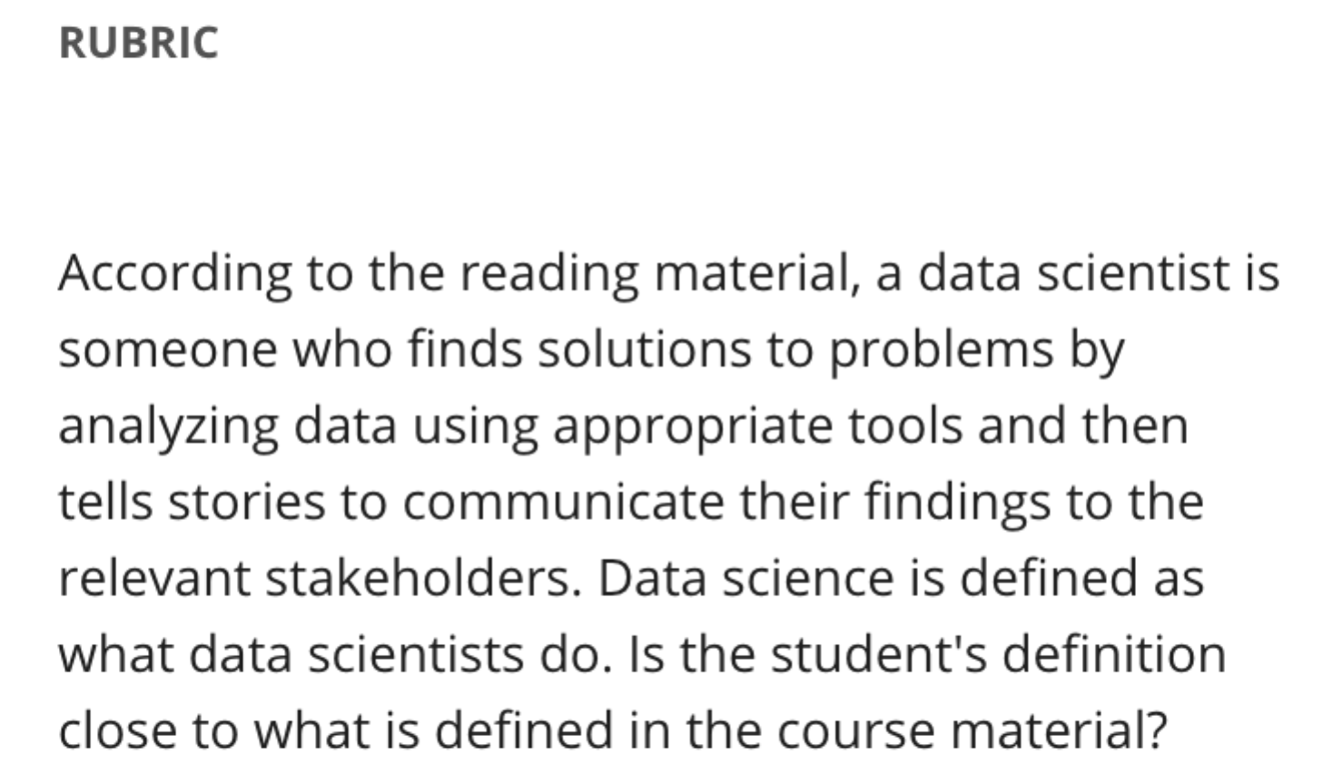

As discussed in the videos and the reading material, data science can be applied to problems across different industries. What industry are you passionate about and would like to pursue a data science career in? **(1 mark)**

**I am interested in applying the data science in the Health sector.**

Based on the videos and the reading material, what are the **ten** main components of a report that would be delivered at the end of a data science project? **(5 marks)**

1. **Cover page**
2. **Table of contents**
3. **Introduction**
4. **Methodology**
5. **Results**
6. **Discussion**
7. **Conclusion**
8. **References**
9. **Acknowledgment**
10. **Appendix**

